2 persons / 599 kcal per person

Ingredients:
- 60 grams of Greek yogurt
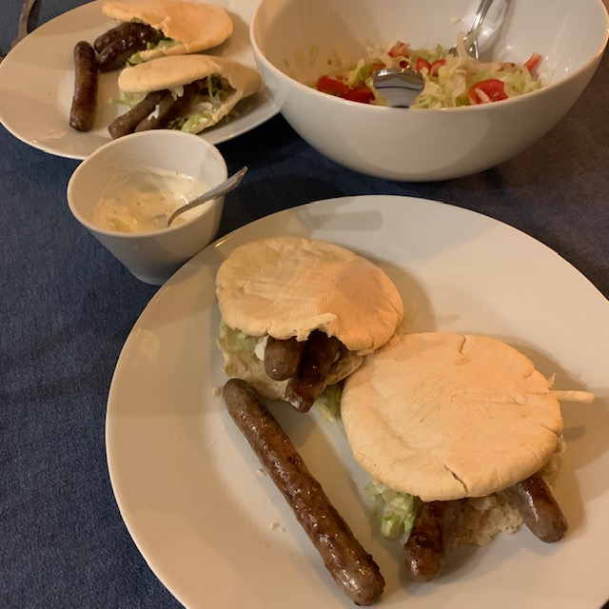
- 1 clove of garlic
- 100 grams of iceberg lettuce
- 2 tomatoes
- ½ onion
- 6 beef chipolata sausages
- 4 pita bread
- pepper and salt

Preparation:
Cut the tomatoes into wedges, the onion into half rings and the garlic fine. Heat the grill plate. Mix the yogurt with the garlic and salt and pepper to taste. Mix the lettuce with the tomato and onion. Roast the sausages on the grill plate for about 5 minutes until brown and done. Turn regularly. In the meantime, toast the pita bread in the toaster or oven, as described on the package. Cut the bread open and fill it with some salad, 1 sausage and some garlic sauce. Serve the rest of the salad, sausages and garlic sauce separately.

Nutritional value per person:
Energy: | 599 kcal
Protein: | 32.6 grams
Carbohydrates: | 55.8 grams
- including sugars: | 6.7 grams
Fat: | 26.0 grams
Fiber: | 4.8 grams
Salt: | 2.9 grams

