2 persons / 571 kcal per person

Ingredients:
- 500 grams waxy potatoes
- 350 grams of green beans
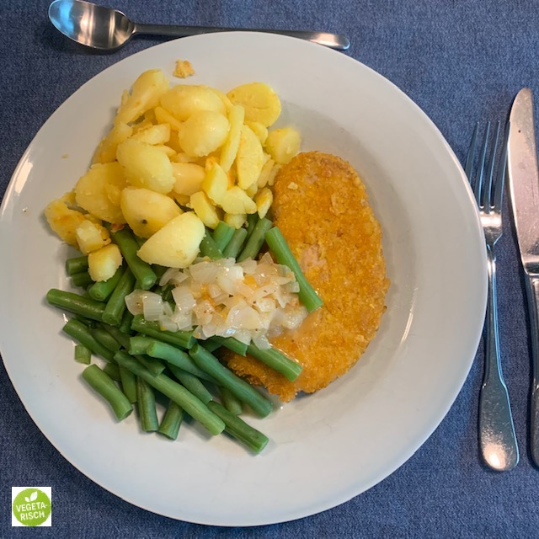
- 2 tablespoons of olive oil
- 2 pieces of vegetarian schnitzel "Vivera"
- ½ onion
- ½ teaspoon of mustard
- 1 tablespoon of apricot spread
- water
- pepper and salt

Preparation:
Boil the potatoes in water with salt for 13 minutes until just done. Drain the potatoes and cut into slices. Heat 1 tablespoon of oil in a frying pan and fry the potato slices for about 12 minutes until golden brown and crispy. Cook the green beans al dente for 8 minutes. Meanwhile, heat the remaining oil in another frying pan. Bake the schnitzel for 6 minutes. Keep the schnitzel warm on a plate covered with aluminum foil. Chop the onion. Fry the onion in the shortening. Add 60 ml water, mustard and the apricot spread and reduce for 2 minutes. Season with salt and pepper. Divide the cutlets between 2 plates. Serve with the green beans and baked potatoes and pour the apricot gravy over it.

Nutritional value per person:
Energy: | 571 kcal
Protein: | 21.5 grams
Carbohydrates: | 76.6 grams
- including sugars: | 8.4 grams
Fat: | 19.2 grams
Fiber: | 15.0 grams
Salt: | 2.4 grams

