2 persons / 585 kcal per portion

Ingredients:
- 1 tablespoon oil
- 200 grams chicken thigh
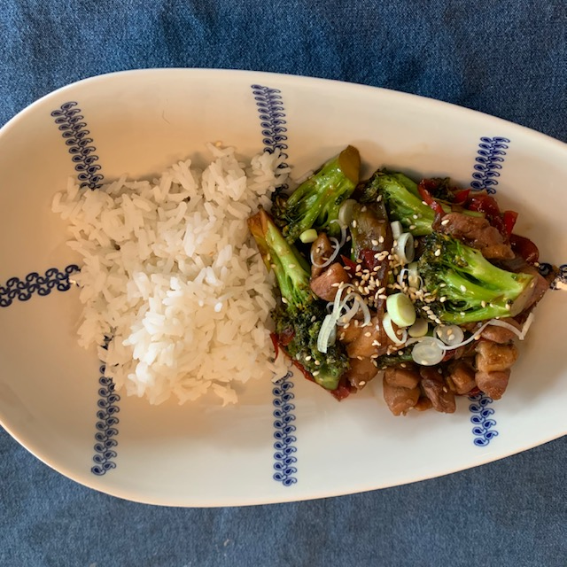
- 1 clove of garlic
- 60 grams soy sauce
- 50 grams honey
- 1 tablespoon sesame seeds
- 1 onion
- 1 bell pepper
- 250 grams broccoli
- ½ spring onion
- 120 grams pandan or white rice
- salt and pepper

Preparation:
Cut the chicken thigh into cubes. Finely chop the garlic. Cut the onion in half rings. Cut the bell pepper into thin strips. Cut the broccoli into small florets. Cut the spring onion into thin slices. Cook the rice according to the description on the package. Roast ½ tablespoon of sesame seeds brown in a dry frying pan, let it cool on a piece of paper towel. Heat the oil in a skillet and fry the chicken over medium heat until cooked. Season with salt and pepper. Reduce the heat and stir in the garlic and fry briefly. Add the soy sauce, honey and ½ tablespoon of sesame seeds. Stir until thickened. Remove the chicken from the pan, leave the sauce and put the vegetables in the pan. Stir fry for 1 minute and cover the pan for 5 minutes and cook until the vegetables begin to soften. Then remove the lid and add the chicken, stirring until the sauce is thick again and the chicken warmed up. Divide the rice, vegetables and chicken. Top with a pinch of sesame seeds and sliced spring onion.

Nutritional value per portion:
Energy: | 585 kcal
Protein: | 66.2 grams
Carbohydrates: | 148.3 grams
- including sugars: | 49.1 grams
Fat: | 31.1 grams
Fiber: | 12.5 grams
Salt: | 10.4 grams

